YOLO Model Fine-Tuning & Inferencing Report
Name: Lo Zhi Hao
Date: 27/2/2025

1. Model Training & Fine-Tuning Summary
- Base Model Used: YoloV8
- Dataset Used: augmented_dataset.zip
- Training Parameters:
  - Batch Size: 64
  - Epochs: 50
  - Image Size: 1280px (Width) x 720px (Height)
  - Augmentations Applied: Left-Right and Top-Down Mirroring
  - Optimizer & Learning Rate: ‘Adam’ Optimizer & LR = 0.001
- Loss Reduction Over Epochs:
  - Initial Loss: (Box_Loss) (Cls_Loss)
  - Final Loss: (Box_Loss) (Cls_Loss)
  - Graph of loss progression:
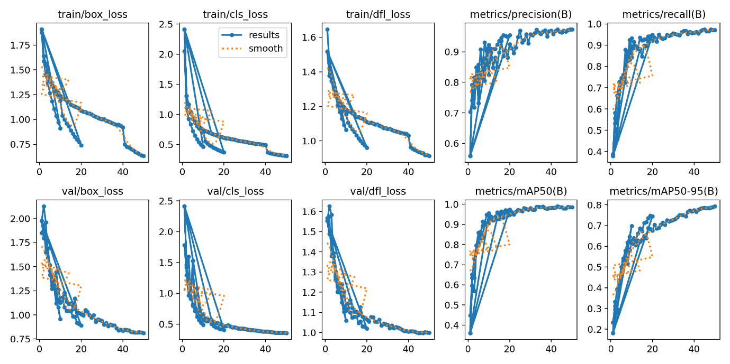

2. Inference Performance
2.1 Dataset Information
- Test Dataset Used: inferencing_1.mp4
- Number of Images Tested: 721
- Resolution of Images Used for Testing: 1200px (Width) x 720 (Height)
2.2 Inference Results
Metric | Value
FPS (Frames per Second)
Average Inference Time (ms)
Precision (%)
Recall (%)
mAP@50 (%)
mAP@50-95 (%)
Number of False Positives
Number of False Negatives

- Observations on Inference Quality:
(Does it detect all expected objects? Are there misclassifications?)
Yes, misclassifications are noted, and are particularly prominent for the salad green and salad purple classes. This may be a case of class imbalance where we have significantly higher number of the salad greens and salad purples in our training dataset, causing the model results to be biased. The model has a tendency to identify background object as SKUs as well. For falsely identified background images, generally they are classified as salads. It may be due to prediction biases where the larger number of training dataset had an effect.
- Example Detections (Screenshots with annotations attached)
- 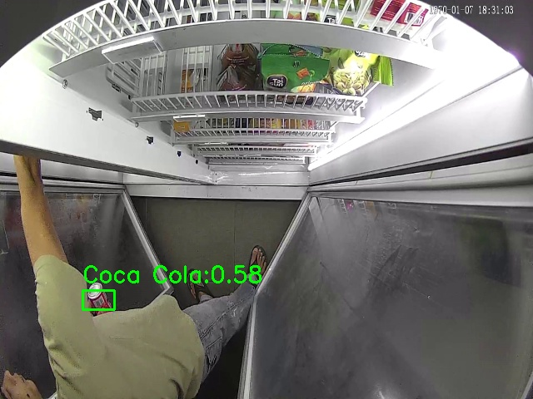

- 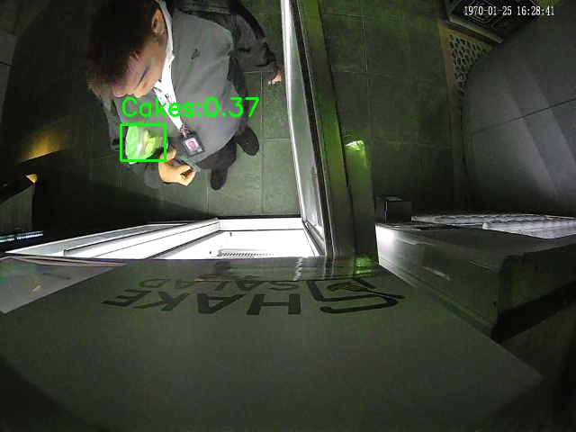
- 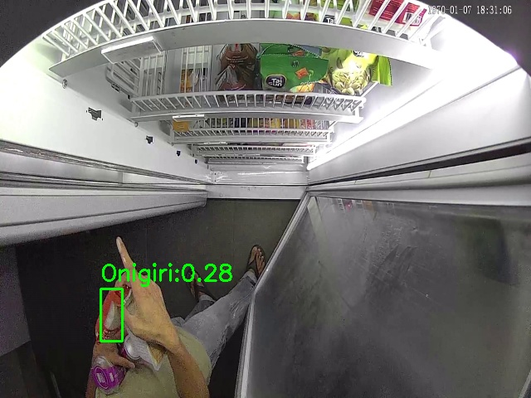
- 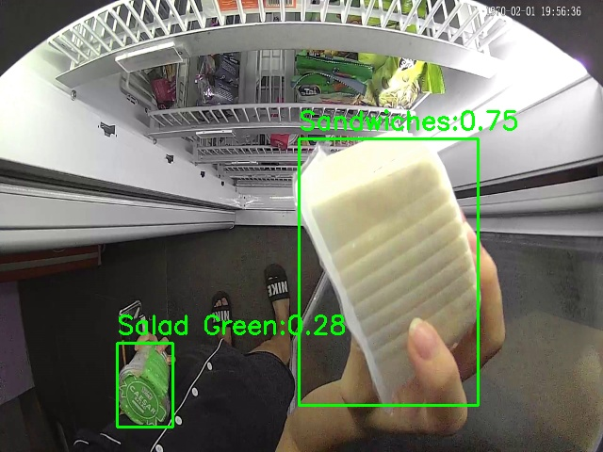
- 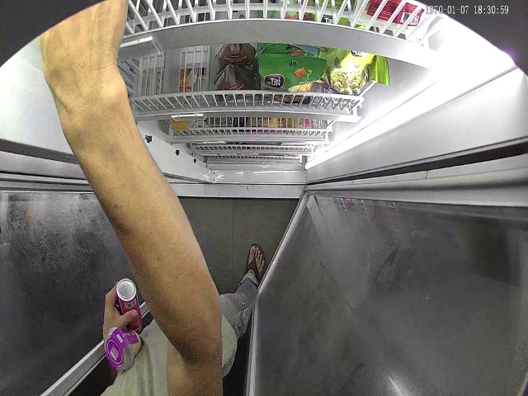
- 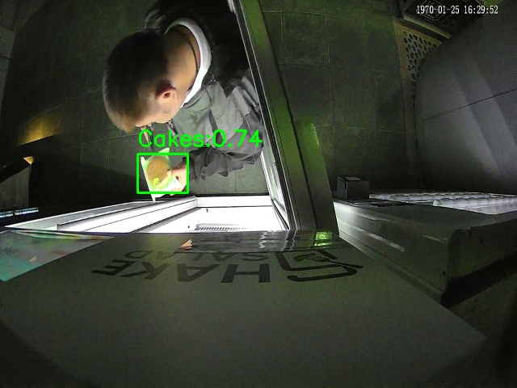

3. Model Performance Comparison
Metric | Pre-Fine-Tuning | Post-Fine-Tuning
Training Loss
mAP@50
FPS

- Performance Gains Observed (if any):

4. Issues & Challenges
- Any anomalies in detection?
Generally, the model is not very satisfying in identifying the object.
- Dataset-related issues?
Imbalanced distribution of SKUs had an effect on the final model performance. The model is more likely to predict the SKU with higher number of training data (salad green and salad purple).
- Overfitting/underfitting observed?
Potential overfitting issues based on eye checks, but generally no signs of overfitting from the loss plots. Had experimented with different epochs and batch number to identify the issue, but generally in my case, yolo model with batch size 64 and epochs 20/50 generally works best. Generally however, the model results are not satisfying.
- Any other difficulties faced? N/A

5. Next Steps & Recommendations
- Suggestions for further improvements:
There are two parts to potentially work on and modify. Firstly, performances of the model across SKU classes varies. This may be because of unbalanced dataset where number of frames collected for different SKUs differs, causing potential overfitting to the majority SKU class. This can be observed with the high number of predictions and tendency for the model to predict for salad green and salad purple which are the SKUs with the greatest number of frames in the dataset as compared to the rest of the SKUs.
Second part may be a concern for high false positives in the background class, as shown in this confusion matrix. However, from eye checks, it seems like increasing the number of training epochs have had an effect on reducing the misidentification of background items as SKUs, which may be a sign of improved model performance.
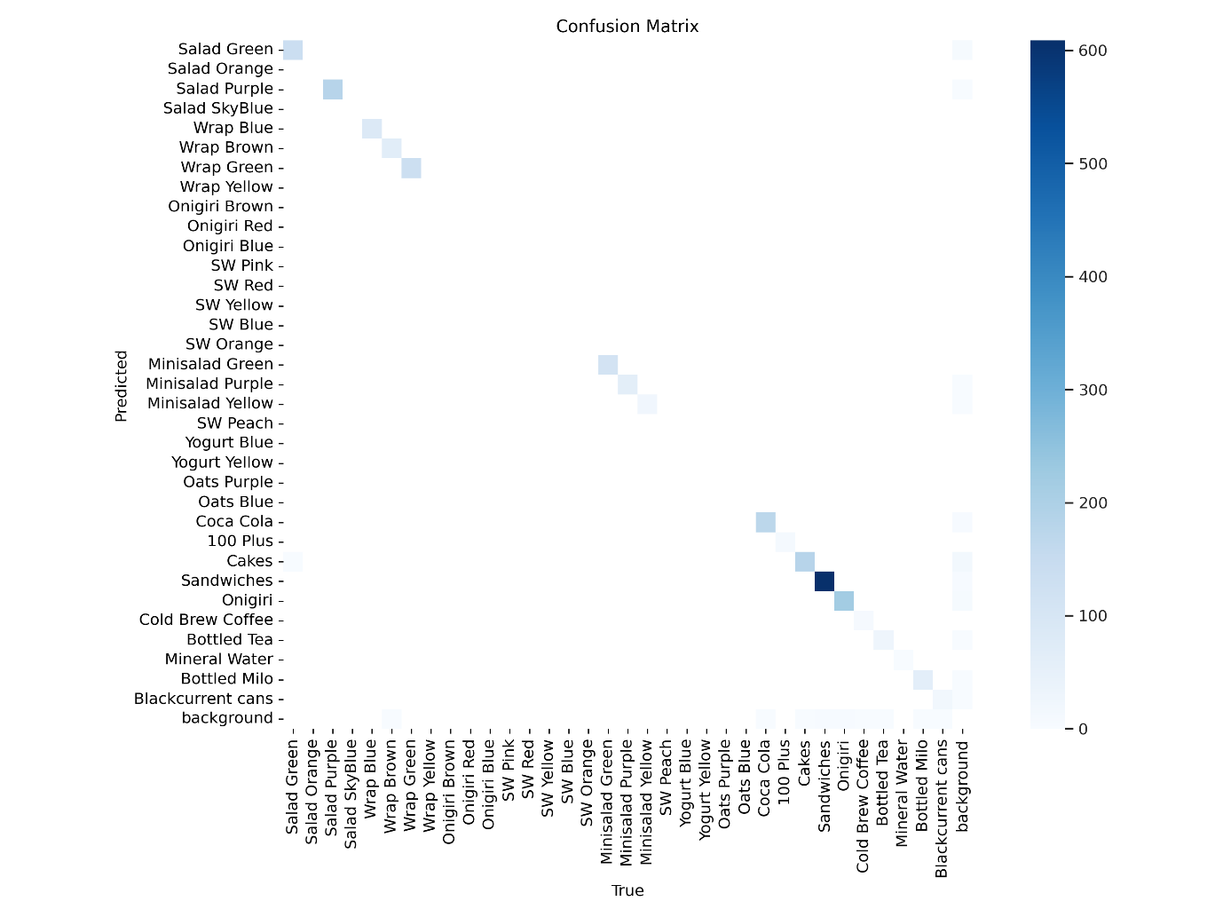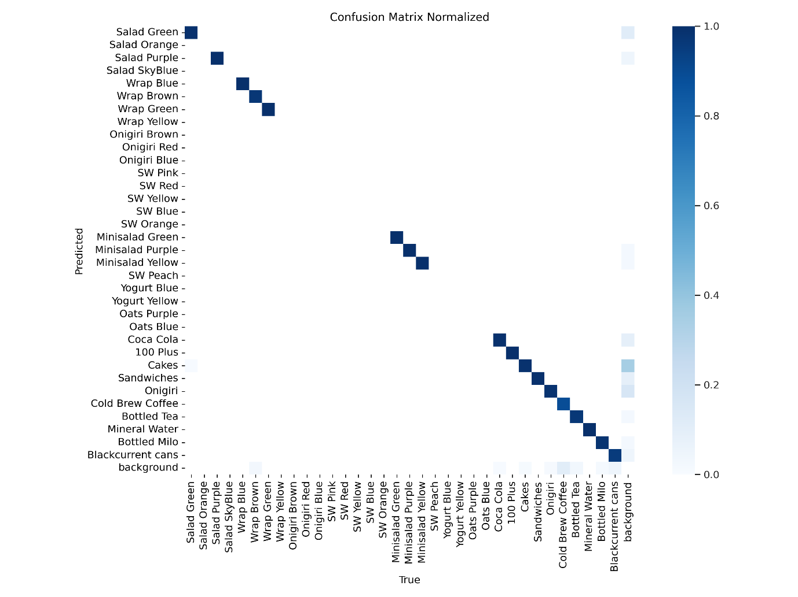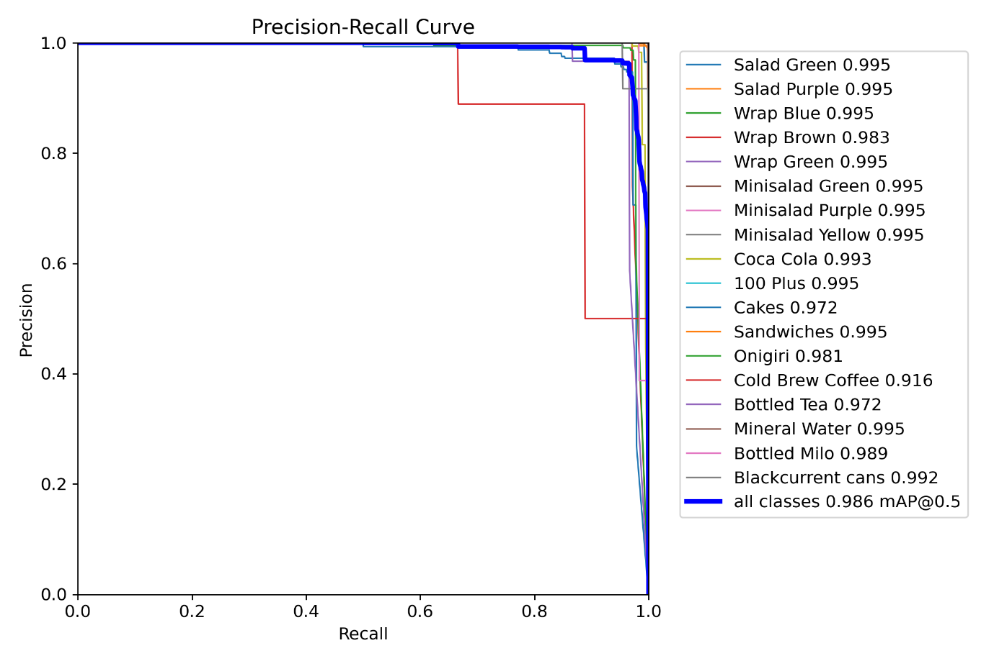

- Need for additional training or dataset enhancement?
I am currently working on removing duplicated data. After that, data augmentation (left/right, top/down) would be applied before using the dataset for model training.
- Hardware or software limitations noticed? N/A
- Plan for the next iteration:
The upcoming course of actions is as follows:
1. An important part of model training is to identify a qualitative metrics to optimise for in my opinion. Thus, I will work on manual labelling the current inferencing video, such that I can present a more qualitative performance review in the upcoming days. This is to come up with a qualitative review of the actual test set (misclassification, box loss, class loss) to make the results different models comparable. I am also working on removing the majority of background frames as well for better evaluation.
2. I am currently working on my methodology to removing additional data, which is using a cosine similarity measure on yolo generated embeddings to identify similar frames and deleting them automatically. Am currently still in the midst of experimenting it and making it work.
3. Next steps would be to generate a more balanced dataset for training. From there on, the yolo training will resume, and further evaluations will be done by then.
4. An important consideration is to have multiple SKUs in the same frame in order for more training on this aspect. It would be great if we have more training data on that.

Notes / Additional Comments
(Any extra remarks or insights)
N/A

